 | ASIAN PARLIAMENTARY ASSEMBLY | 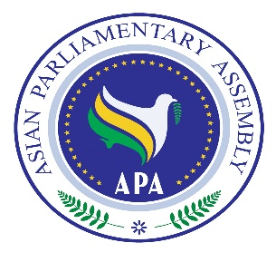
1st Executive Council Meeting
4-6 October 2018
Izmir - Turkey

Agenda

- Adoption of the Agenda
- Election of the Bureau
- Remarks by the Chairman of the Executive Council
- Report of the APA Secretary-General
- Consideration and Recommendation of the Draft Resolutions proposed by:

- Standing Committee on Economic and Sustainable Development Affairs
- Standing Committee on Social and Cultural Affairs

- Adoption of the Report of the meeting
- Any other matter
- Closing

As 1 September 2018

